Feedback from Muhammed

I wont lie the work you have done is excellent and requires very few improvements. If I nitpick the two areas you can work on tomorrow would be the UAC where you could break them down further into exactly what pages need to be made buttons what the users should see and more. Then the other area would be to just tighten up the wire frames by making more you already have a good number of them but maybe other pages like forgot password and user profile, order history, delivery tracking page and maybe even a page for the basket before they order so we can see how all them look.
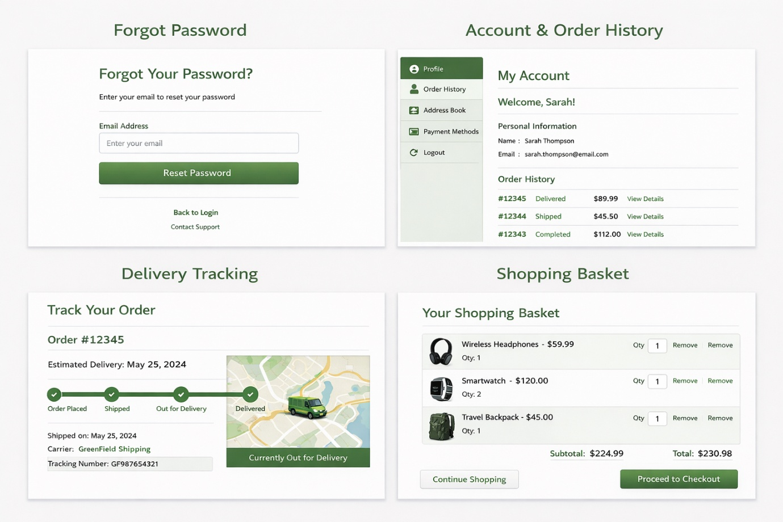

User Acceptance Criteria
Page: Registration Page
- User selects the “Register” button from the homepage or login page
- System displays a registration form with the following fields:
  - Full Name
  - Email Address
  - Password
  - Confirm Password
  - Checkbox: “Register as Producer”
- If “Register as Producer” is selected, additional fields appear:
  - Business Name
  - Product Type
  - Location
- User clicks the “Create Account” button
Validation Rules
5. System validates:
- Email contains “@” and valid format
- Password is at least 8 characters
- Password and Confirm Password match
- If validation fails:
  - Error messages displayed next to fields
  - User cannot proceed
Successful Registration
7. If validation passes:
- Account is created and stored securely
- Password is encrypted
- System displays confirmation message:
  - “Registration successful”
- User is redirected to the Login Page

🔑 Functional Requirement: Login

User Story
As Emily, I want to log in so that I can view my orders and place new ones.
As Liam, I want to log in so that I can manage my products and stock.

User Acceptance Criteria
Page: Login Page
- User navigates to login page
- User enters:
  - Email
  - Password
- User clicks “Login” button
System Behaviour
4. System checks credentials against database
- If correct:
  - User is logged in
  - Redirected to:
    - Customer Dashboard OR
    - Producer Dashboard
- If incorrect:
  - Error message displayed:
    - “Invalid email or password”
- After 5 failed attempts:
  - Account is temporarily locked

🛒 Functional Requirement: View Products

User Story
As Emily, I want to view products so that I can make informed purchasing decisions.

User Acceptance Criteria
Page: Product Catalogue
- User accesses product page from homepage
- System displays list of products showing:
  - Product name
  - Price
  - Stock availability
  - Producer name
- User can:
  - Scroll through products
  - Use filters:
    - Category
    - Producer
- User clicks a product
Page: Product Details
5. System displays:
- Full description
- Price
- Stock level
- Producer information
- Traceability details
- User sees “Add to Basket” button

🧺 Functional Requirement: Place Order

User Story
As Emily, I want to place an order so that I can receive products without visiting the store.

User Acceptance Criteria

Page: Product Page
- User selects product
- User selects quantity
- User clicks “Add to Basket”

Page: Basket Page
- System displays:
  - List of selected products
  - Quantity of each item
  - Individual prices
  - Total cost
- User can:
  - Increase/decrease quantity
  - Remove items
- User clicks “Proceed to Checkout”

Page: Checkout Page
- User selects:
  - Delivery OR Collection
- User confirms details
- User clicks “Place Order”

System Actions
- System:
- Saves order
- Updates stock automatically
- Sends notification to producer
- User sees confirmation message:
- “Order placed successfully”

💳 Functional Requirement: Payment Handling

User Story
As James, I want to pay securely online so that I can complete my order.

User Acceptance Criteria
Page: Payment Page
- User selects payment method:
  - Card
  - Online payment option
- User enters:
  - Card number
  - Expiry date
  - CVV
- User clicks “Pay Now”
System Behaviour
4. Payment is securely processed
- If successful:
  - Payment confirmation displayed
  - Order marked as paid
- If failed:
  - Error message displayed
  - User prompted to retry

📦 Functional Requirement: Order Tracking

User Story
As Emily, I want to track my order so that I know when it will arrive.

User Acceptance Criteria
Page: Order Tracking Page
- User selects an order from order history
- System displays:
  - Order status:
    - Pending
    - Processing
    - Ready
    - Delivered
- Visual progress indicator shown
- Estimated delivery/collection time displayed
- System updates status in real-time

👤 Functional Requirement: Manage Account

User Story
As James, I want to update my account details so that my information stays accurate.

User Acceptance Criteria
Page: Profile Page
- User navigates to “My Account”
- System displays:
  - Name
  - Email
  - Address
- User clicks “Edit Profile”
- User updates details
- User clicks “Save Changes”
- System validates input
- Confirmation message displayed:
  - “Details updated successfully”

